Task1:

CREATE TABLE STAFF (
StaffID INT,
FullName VARCHAR(100),
PhoneNumber VARCHAR(10)
);

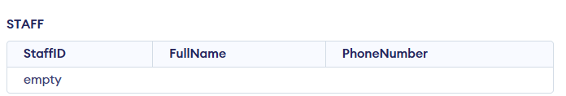

Task2:
ALTER TABLE STAFF ADD ROLE VARCHAR(20);
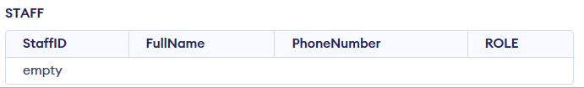

Task3:
ALTER TABLE STAFF DROP COLUMN PhoneNumber;